**Class Four - 11/30/2020**

**Monthly Goals**

* Practice, practice, practice!
* Master the citizenship questions (prepare for a practice test in January)
* Continue to add words to your vocab list

**Warm Up:**

* Conversation Practice
  + Mock phone call with a teacher

**Reading Practice**

# *Citizenship Rights and Responsibilities*

# (from the US Citizenship and Immigration Services website)

Citizenship is the common thread that connects all Americans. We are a nation bound not by race or religion, but by the shared values of freedom, liberty, and equality.

Throughout our history, the United States has welcomed newcomers from all over the world. Immigrants have helped shape and define the country we know today. Their contributions help preserve our legacy as a land of freedom and opportunity. More than 200 years after our founding, naturalized citizens are still an important part of our democracy. By becoming a U.S. citizen, you too will have a voice in how our nation is governed.

The decision to apply is a significant one. Citizenship offers many benefits and equally important responsibilities. By applying, you are demonstrating your commitment to this country and our form of government.

Below you will find several rights and responsibilities that all citizens should exercise and respect. Some of these responsibilities are legally required of every citizen, but all are important to ensuring that America remains a free and prosperous nation. 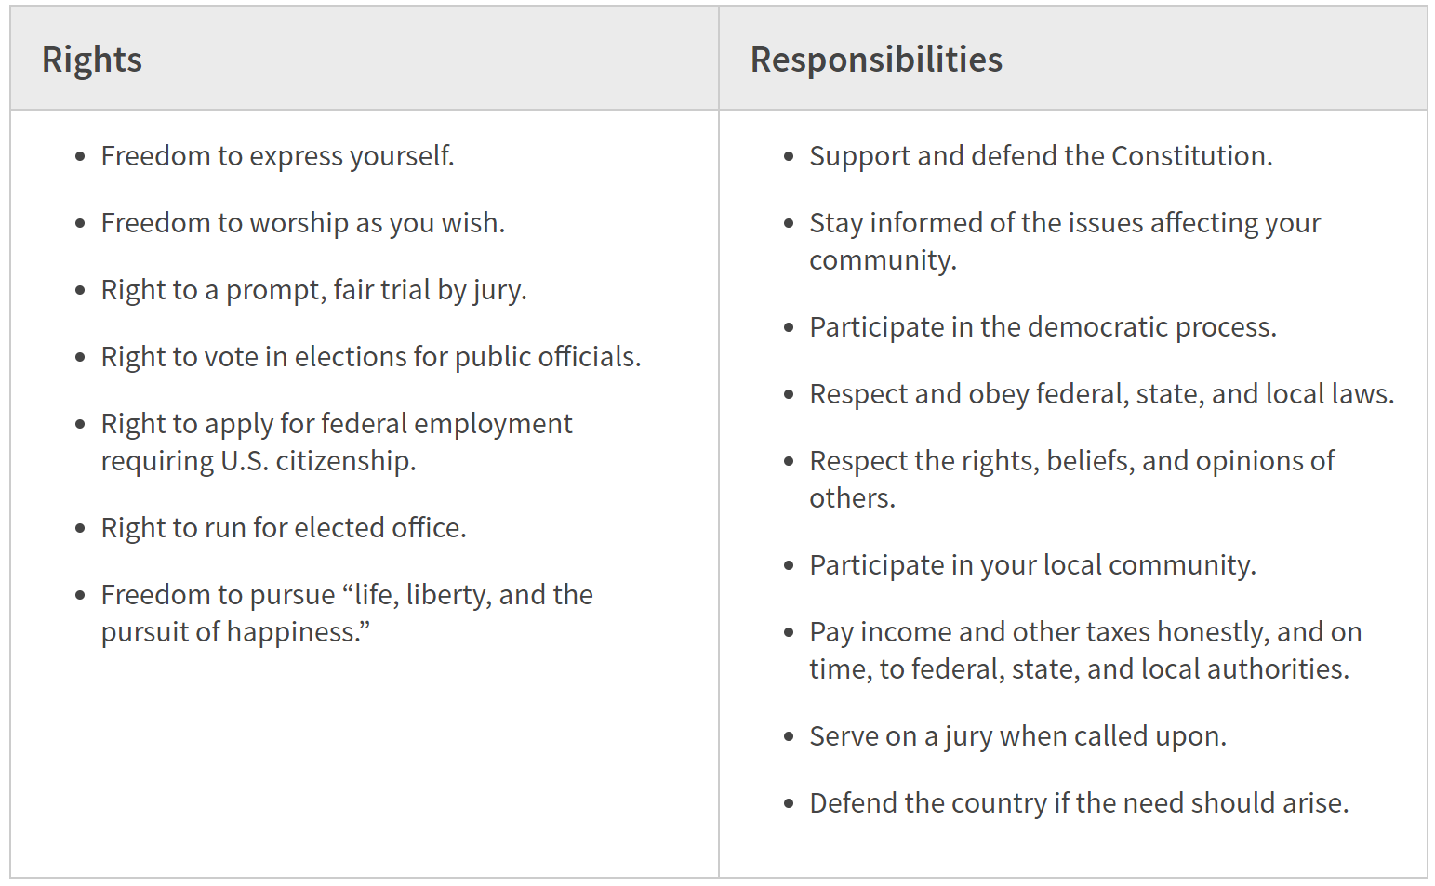

**Citizenship Test Practice**

* What is ONE responsibility that is only for US citizens? (serve on a US jury, vote in a US federal election)
* Name ONE right only for US citizens? (vote in a US federal election, run for US federal office)
* What did the Declaration of Independence do? (Announced our independence from Great Britain/said the US is free from GB)
* What are two rights in the Declaration of Independence? (Life, liberty, pursuit of happiness)
* What is Freedom of Religion? (You can practice any religion, or practice no religion)
* What is the economic system in the United States? (Capitalist/Market economy)
* What is the rule of law? (Everyone must follow the law / Leaders and Government must also follow the law / Nobody is above the law)
* Who is one of your State’s senators right now? (Ed Markey, Elizabeth Warren)
* Name your US representative? (William Keating for Plymouth?)
* What are two rights of everyone living in the United States? (Freedom of expression/Freedom of speech/freedom of assembly/freedom to petition the government/freedom of religion/the right to bear arms)
* What do we show loyalty to when we say the **Pledge of Allegiance**? (The US, the flag)
* What is one promise you make when you become a US citizen?
  + Give up loyalty to other countries
  + Defend the Constitution and the laws of the USA
  + Obey the US laws
  + Serve in the US military (if needed)
  + Serve the nation
  + Be loyal to the United States
* How old do citizens have to be to vote for President? (18 years old)
* What are two ways Americans can participate in their democracy? (Voting, contacted elected officials)
* When is the last day you can send in federal income tax forms? (April 15th)
* When must all men register for the Selective Service? (18 and 26)

**Speaking Practice**

Based on the reading above and our citizenship test practice, I want you to give a one minute long speech on the history of the civil rights movement. Include key events and people. You will have two minutes to prepare notes to use for the speech. Be sure that the speech flows and that it is not just a list of facts.

Transition words to try to use (at least two) in your speech:

* Therefore
* Next
* However
* In this way
* In contrast
* Also
* Furthermore
* Additionally

**Class Three - 11/16/20**

**Weekly Goals:**

* Keep working on speaking English every day
* Do citizenship test practice
* Add words to your vocab list

**Warm Up:**

* What was one conversation you had this week?
* Share vocab words you have added to your list over the last few weeks
* Go over homework (finishing list of irregular past participles)

**Reading and Summarizing Practice**

From History.com:

The civil rights movement was a struggle for social justice that took place mainly during the 1950s and 1960s for Black Americans to gain equal rights under the law in the United States. The Civil War had officially abolished slavery, but it didn’t end discrimination against Black people—they continued to endure the devastating effects of racism, especially in the South. By the mid-20th century, Black Americans had had more than enough of prejudice and violence against them. They, along with many white Americans, mobilized and began an unprecedented fight for equality that spanned two decades.

Summary: There was a movement in 1950 where Black people continued to fight to gain their rights because there (*still*) was discimination against them (*even though slavery had been abolished*).

**Citizenship Practice**

* Why did the colonists fight the British?
  + The high taxes/taxation without representation
  + Because they did not have self-government
  + Because the British army stayed in their houses (boarding/quartering)
* Name 3 out of the 13 original states: (New Hampshire, Massachusetts, Rhode Island, Connecticut, New York, New Jersey, Pennsylvania, Delaware, Maryland, Virginia, North Carolina, South Carolina, Georgia)
* What happened at the Constitutional Convention? (The Founding Fathers wrote the Constitution)
* What did the Emancipation proclamation do?
  + Freed the slaves/freed slaves in the confederacy/freed slaves in the confederate states/freed states in most Southern States
* What did Susan B Anthony do? (Fought for civil rights, fought for women’s rights)
* What movement tried to end racial discrimination? (Civil Rights Movement)
* What did Martin Luther King Jr. do? (fought for civil rights, worked for equality for all Americans, worked on rights for Black people)
* What major event happened on September 11th, 2001, in the US? (9-11; Terrorists attacked the United States at the Pentagon, the Twin Towers, etc.)
* Name ONE American Indian (Native American) tribe in the United States
  + Cherokee, Navajo, Sioux, Chippewa, Choctaw, Pueblo, Apache, Iroquois, Creek, Blackfeet, Seminole, Cheyenne, Arawak, Shawnee, Mohegan, Huron, Oneida, Lakota, Crow, Hopi, Teton, Inuit
* What is one reason colonists came to America? (Freedom/political liberty/religious freedom/economic opportunity/practice their religion/escape persecution)
* Who lived in America before the **Europeans** arrived? (**Native Americans)**
* What group of people was taken to America and sold as slaves? (Africans/People from Africa

**Speaking Practice**

Based on the reading above and our citizenship test practice, I want you to give a one minute long speech on the history of the civil rights movement. Include key events and people. You will have two minutes to prepare notes to use for the speech. Be sure that the speech flows and that it is not just a list of facts.

Transition words to try to use (at least two) in your speech:

* Therefore
* Next
* However
* In this way
* In contrast
* Also
* Furthermore
* Additionally

**Class Three - 11/16/20**

**Weekly Goals:**

* Keep working on speaking English every day
* Do citizenship test practice (that I will actually remember to send to you)
* Add words to your vocab list

**Warm Up:**

* How was your week? How is your real estate class going?
* Share vocab words you have added to your list over the last few weeks
  + Use three of the words in a sentence

**Grammar Topic - Using Have/Has and past participles**

## **How to remember irregular verbs and irregular past participles**

(from <https://www.english-at-home.com/grammar-irregular-past-participles/>)

Most irregular verbs are very common in English, which means you will see or hear them often. This makes it a little easier to remember them. But there are also some common patterns:

– the ‘en’ ending (break – broke – broken; write – wrote – written; hide – hid – hidden etc)

– the ‘ing’, ‘ang’, ‘ung’ pattern (ring – rang – rung; sing – sang – sung etc)

Some common verbs are also formed from others, which means the past participle is the same:

– give / forgive (given / forgiven)

– come / become (come / become)

– stand / understand (stood / understood)

A few verbs don’t change at all. For example:

read – read – read (the pronunciation changes from the present /reed/ to the past tense and past participle /red/

cut – cut – cut (no pronunciation change)

put – put – put (no pronunciation change)

Sometimes, more than one ending is possible:

– *dreamed* / dreamt

– *learned* / learnt

**Reading and Summarizing Activity:**

From <https://www.whitehouse.gov/about-the-white-house/the-constitution/>

*Why a Constitution?*

The need for the Constitution grew out of problems with the Articles of Confederation, which established a “firm league of friendship” between the states, and vested most power in a Congress of the Confederation. This power was, however, extremely limited — the central government conducted diplomacy and made war, set weights and measures, and was the final arbiter of disputes between the states. Crucially, it could not raise any funds itself, and was entirely dependent on the states themselves for the money necessary to operate. Each state sent a delegation of between two and seven members to the Congress, and they voted as a bloc with each state getting one vote. But any decision of consequence required a unanimous vote, which led to a government that was paralyzed and ineffectual.

A movement to reform the Articles began, and invitations to attend a convention in Philadelphia to discuss changes to the Articles were sent to the state legislatures in 1787. In May of that year, delegates from 12 of the 13 states (Rhode Island sent no representatives) *convened* in Philadelphia to begin the work of *redesigning* government. The delegates to the Constitutional Convention quickly began work on drafting a new Constitution for the United States.

Summary: The constitution was redesigned because it was extremely limited in its power. The 13 colonies, except Rhode Island, sent representatives to begin the work of redesigning the government.

**Citizenship Practice:**

* What is the supreme law of the land? (The Constitution)
* When was the Constitution written? (1787)
* What does the Constitution do? (Sets up the government, defines the government, protects basic rights of Americans)
* The Federalist Papers supported the passage of the US Constitution. Name one of the writers. (James Madison, Alexander Hamilton, John Jay, Publius)
* The idea of self-government is the first three words of the Constitution. What are these three words? (We The People)
* What is an Amendment? (A change or addition to the constitution)
* What do we call the first 10 Amendments to the Constitution? (The Bill of Rights)
* What is one right or freedom from the First Amendment? (Speech, religion, assembly, press, to petition the government)
* How many Amendments does the Constitution have? (27)
* There are four amendments to the Constitution about who can vote. Describe ONE of them (Any citizen can vote - men and women, a male citizen of any race can vote, you don’t have to pay poll tax to vote, citizens eighteen and older can vote)

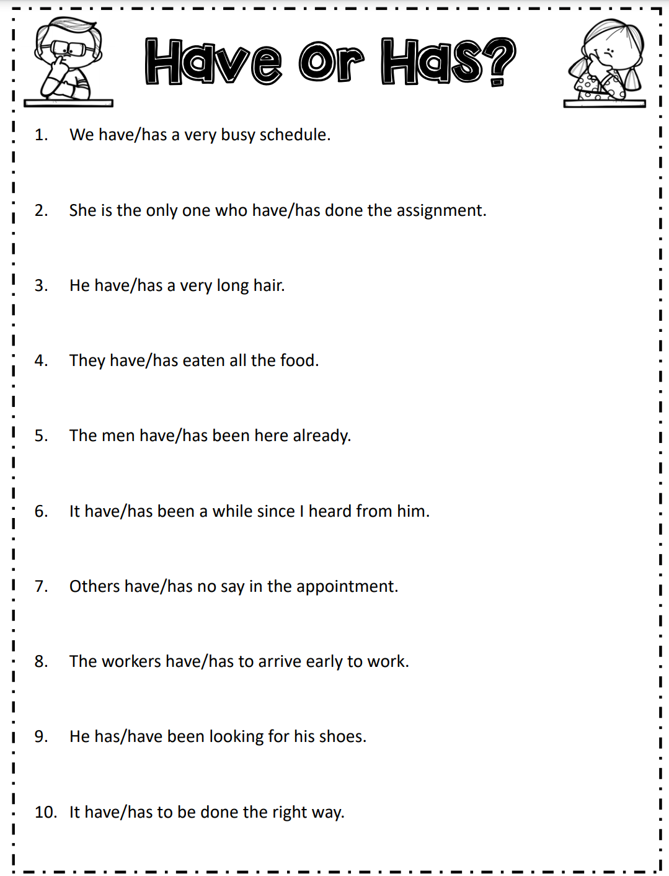

**Class Two - 11/9/20**

**Weekly Goals:**

* Continue to try to speak english with someone each day
* Complete homework

**Warm Up:**

* Reflect on last week’s goals. How did you do? Did you meet your goals? What grade would you give yourself? Was the workload too much, not enough, or just right?
  + Vocab List
    - Lots of new words related to real estate
  + Speaking english every day
  + Article homework

**Grammar Topic of the Day - Irregular Verb Tenses:**

Here are some examples of irregular verbs in the present/past tenses that you may have heard used before:

**Practice:** (write the past tense and future tense version of each word)

* I am
  + I was, I going to/I will
* I write
  + I wrote, I will write
* I draw
  + I drew, I will draw
* I do
  + I did, I will do
* I make
  + I made, I will make
* I meet
  + I met, I will meet
* I pay
  + I paid, I will pay
* I send
  + I sent, I will send
* I sleep
  + I slept, I will sleep
* I stand
  + *I stood*, I will stand
* I read (reed)
  + I read (red), I will read (reed)
* I cut
  + I cut, I will cut
* I buy
  + I *bought*, I will buy
* I see
  + I saw, I will see

Pick two words from the above list and write a complete sentence using the past tense form.

** Next week: past participles (I have, I had)

Answers:

* **Present → Past**
* I am/he is/we are → I was/he was/we were
  + I am a worker. → I was a student.
  + I am reading the book. → I was watching TV.
* I write → I wrote
  + I write in my notebook. → I wrote a letter.
* I draw → I drew
  + I draw a flower. → I drew a house.
  + Past tense words: yesterday, last week, (anything that describes a day that is before today)
* I do → I did
  + I do exercise. → I did (had) a barbecue.
* I make → I made
  + I make a cake. → Yesterday I made chicken.
* I meet → I met
  + I meet my neighbor. → Three years ago, I met my husband!
  + Present tense words: today, right now…
* I pay → I paid
  + Today I pay for my car. → Yesterday I paid my security deposit.
* I send → I sent
  + I send mail. → I sent a letter.
* I sleep → I slept
  + Today I go to sleep early. → Yesterday I slept late.
  + I sleep in my bed. → I slept in that bed.
* I stand → I stood
  + I stand all day. → Yesterday I stood all day.
  + I stand in line at the store. → Yesterday, I stood in line at the store.
* I read (sounds like reed) → I read (sounds like red)
* I cut → I cut
  + I cut with scissors. → Yesterday I cut my hair.
* I buy → I bought (sounds like bot)
  + I buy food today. → Last week I bought food at the store.
* I see → I saw
  + I see you right now. → I saw my mom yesterday.

Let’s talk out some examples of sentences using both the present and past forms of these verbs to practice the irregular forms!

* I pay my bills every month. → I paid the bills last month.
* I stand in line at the store. → Yesterday, I stood in line at the store.
* I send a letter to my sister to see how she is doing. → I sent a letter in the mail.

Video with a large list of irregular verbs in a song!

* <https://www.youtube.com/watch?v=MA3NFtLc22k>

**Citizenship Test Activity:**

I will read questions, you write down the answers.

1. We elect a president for how many years? (Four)
2. In what month do we vote for President? (November)
3. What is the name of the President of the United States right now? (Donald Trump, Trump, Donald J. Trump)
4. What is the name of the Vice President of the United States right now? (Mike Pence, Pence, Michael R. Pence)
5. If the President can no longer serve, who becomes the President? (The Vice President)
6. If both the President and Vice President can no longer serve, who becomes the President? (The Speaker of the House of Representatives)
7. Who is the Commander in Chief of the military? (The President)
8. Who signs bills to become laws? (The President)
9. Who vetoes bills? (The President)
10. What does the president's cabinet do? (Advises the president)
11. What are two Cabinet-level positions?
    1. Secretary of Agriculture/Commerce/Defense/Education/Energy/Health and Human Services/Homeland Security/Housing and Urban Development/Interior/Labor/State/Transportation/Treasury/Veterans Affairs
    2. Attorney General
    3. Vice President
12. What is the political party of the President right now? (Republican)
13. Who is in charge of the executive branch (the President)
    1. Bonus: what are the other two branches? (legislative and judicial)
    2. How many judges are there? 9
14. Who was President during WWI? (Woodrow Wilson)
15. Who was President during the Great Depression and WWII? (Franklin D Roosevelt)
16. Before he was President, Eisenhower was a general. Which war did he fight in? (WWII)

**Homework:**

1. Continue to add new words to your list
2. Continue to push yourself to speak in English whenever you can
3. Write out three citizenship questions (question and answer) each day. Write out all of the questions first and then quiz yourself by writing down the answer.
4. Read and excerpt about American history each day (I will send you a document with excerpts for each day.

**Class One - 10/26/20**

**Weekly Goals:**

* Start a vocabulary list of new words in English. Definitions have to be written in English, but you can also write notes in portuguese if you want.
* Have at least a five minute conversation in English every day
* Complete your daily homework

**Warm Up:**

*Have you already filled out an N-400 form/have you had an eligibility interview? Waiting to hear back about the date (likely January).*

*Can I share a google doc with you?*

Talking about your week!

* What was the best part of last week?
  + “We spent a few hours very very great.”
    - Correction: “We spend a few hours there. It was really really great.”
    - “Nit-picky” - (Slang) - pointing out small errors/problems
  + “We went to the beach now with my family.”
    - “We went to the beach *then* with my family.”
* What was the worst part?
  + New phrase: “I needed to talk with her about her poor/bad behavior”
* What is your daughter learning in school right now?

**Grammar Topic of the Day - Irregular Verb Tenses:**

Here are some examples of irregular verbs in the present/past tenses that you may have heard used before:

* **Present → Past**
* I am/he is/we are → I was/he was/we were
  + I am a worker. → I was a student.
  + I am reading the book. → I was watching TV.
* I write → I wrote
  + I write in my notebook. → I wrote a letter.
* I draw → I drew
  + I draw a flower. → I drew a house.
  + Past tense words: yesterday, last week, (anything that describes a day that is before today)
* I do → I did
  + I do exercise. → I did (had) a barbecue.
* I make → I made
  + I make a cake. → Yesterday I made chicken.
* I meet → I met
  + I meet my neighbor. → Three years ago, I met my husband!
  + Present tense words: today, right now…
* I pay → I paid
  + Today I pay for my car. → Yesterday I paid my security deposit.
* I send → I sent
  + I send mail. → I sent a letter.
* I sleep → I slept
  + Today I go to sleep early. → Yesterday I slept late.
  + I sleep in my bed. → I slept in that bed.
* I stand → I stood
  + I stand all day. → Yesterday I stood all day.
  + I stand in line at the store. → Yesterday, I stood in line at the store.
* I read (sounds like reed) → I read (sounds like red)
* I cut → I cut
  + I cut with scissors. → Yesterday I cut my hair.
* I buy → I bought (sounds like bot)
  + I buy food today. → Last week I bought food at the store.
* I see → I saw
  + I see you right now. → I saw my mom yesterday.

Let’s talk out some examples of sentences using both the present and past forms of these verbs to practice the irregular forms!

* I pay my bills every month. → I paid the bills last month.
* I stand in line at the store. → Yesterday, I stood in line at the store.
* I send a letter to my sister to see how she is doing. → I sent a letter in the mail.

Video with a large list of irregular verbs in a song!

* <https://www.youtube.com/watch?v=MA3NFtLc22k>

**Writing and Reading Aloud Activity:**

For this activity, we are going to practice both reading aloud in English and comprehending advanced tenses and vocabulary.

Excerpt (a smaller part from a larger piece of writing) from the NYT article, “Biden Pledges Ambitious Climate Action. Here’s What He Could Actually Do.” <https://www.nytimes.com/2020/10/25/climate/biden-climate-change.html>

Words in green are important politics vocab terms.

WASHINGTON — Joseph R. Biden Jr.’s $2 trillion plan to fight global warming is [the most ambitious climate policy](https://www.nytimes.com/2020/07/14/us/politics/biden-climate-plan.html) proposed by a leading presidential candidate, a political lightning rod spotlighted on Thursday night when the Democratic nominee acknowledged during a debate that it would “transition” the country “from the oil industry.”

But no one knows better than Mr. Biden, the former vice president, that it almost surely will not be enacted, even if his party secures the White House and the Senate. Thirty-six years in the Senate and the searing experience of watching the Obama administration’s less ambitious climate plan die a decade ago have taught him the art of the possible.

Still, a President Biden could have real impact: solar panels and wind turbines spread across the country’s mountains and prairies, electric charging stations nearly as ubiquitous as gas stations and a gradual decrease in the nation’s planet-warming greenhouse pollution.

“The oil industry pollutes significantly,” Mr. Biden said at the final presidential debate, adding, “it has to be replaced by renewable energy over time.”

Example HW:

* Surely - used to emphasize a person’s belief that they are correct
* Surly - a person acting rude or annoyed
* Searing
* Senate (pronunciation)
* Prairies
* Ubiquitous

Summary:

Biden is worried about climate change. He wants to support the renewable energy industry.

**Homework:**

Read a new article each day this week. The article can be about anything you want, but it might be helpful to read political articles because they will have vocabulary relevant to your citizenship test. Print the article out. As you read, highlight vocabulary words you don’t recognize and look them up. Then, write a one paragraph summary of the article.

Add new vocabulary words to your list!

Don’t forget to have a couple minute conversation in English each day if you can!